Pokhara University
Level: Bachelor | Semester – Fall | Year : 2009
Programme: B.E. |  | Full Marks: 100
Subject: Computer Network |  | Time : 3hrs.

Candidates are required to give their answers in their own words as far as practicable.
The figures in the margin indicate full marks.
Attempt all the questions.

1. | - Explain different kind of services that are benefited by the networking technology in today's world?  - Explain your personal view to justify any two network topologies which you think is the most important to build a stable network.  - Show the comparison between Intranet, Extranet, Internet and piconet. | 5  5  5
2. | - Give two reasons for using layered protocols and explains the functions of various layers in TCP/IP reference model.  - What is framing? Explain starting and ending flag with bit stuffing with example. | 8  7
3. | - Compare copper wire and fiber optics with respect to the transmission speed, installation/maintenance, security, cost effectiveness, reliability and flexibility.  - Explain different Elementary datalink protocols to show how datalink protocols are developed as per need in different phases of time. | 7  8
4. | - How ISDN interfaces and channel works?  - Define adaptive and non adaptive routing algorithms. Explain shortest path routing algorithm with example. | 7  8
5. | - Sketch the IPV4 frame format and compare it with IPV  - Why sub netting is used in IP? The class c network of 204.15.5.0/24 is given, subnet the network in order to create the network in the given figure with the host requirement shown.  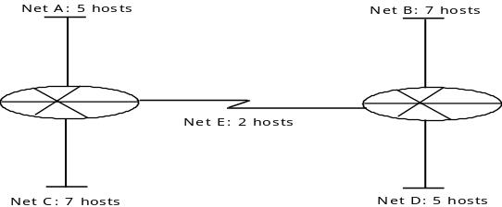 | 7  8
6. | - Discuss the use of firewall in secure Network. What are the two different types of firewall? Explain them briefly.  - Differentiate between HTTP and HTTPS protocol.  - What is distributed processing? | 5  5  5
7. | Write short notes on (Any two)  - OSI vs. TCP/IP  - Virtual circuit and Datagrams  - Symmetric Key encryption | 5×2

